

Hotel Management System
Software Design Document

Name (s):
ESSETTI Yasmine
MASMOUDI Nour
2BI (2024/2025)

Preface

This Cahier de Conception (Design Document) serves as the foundational blueprint for the development of the Hotel Management System (HMS), an efficient software solution designed to facilitate the daily operations of hotels. The goal of this project is to create a system that allows administrators and users to interact seamlessly while managing hotel reservations, user profiles, and room assignments.

The hospitality industry has to deal with large amounts of data and at the same time, demand optimal efficiency in operation. This system is designed to handle these challenges by offering an intuitive, scalable platform that addresses all the needs of both admin staff and end-users alike. Using detailed design and systematic development, the system will streamline processes, provide better customer service, and allow better resource allocation.

In this report, we will present the basic functional and non-functional requirements, the system architecture, use case modeling and security considerations. Also, we will include diagrams to visualize the structure and processes of the system, which will guide those concerned in the development and review of our system.

Table of Contents
preface............................................................................................................................02
Table of contents.................................................................................................03/04
- Introduction
  - 1.1. Purpose of the System................................................................................................05
  - 1.2. Scope of the Project......................................................................................05/06/07
    - 2.2.1. Functional features............................................................................05/06
    - 2.2.2. Non-Functional features...............................................................06/07
  - 1.3. Intended Audience.......................................................................................................08
  - 1.4. Technologies Used.......................................................................................................09
- System Overview...............................................................................................10/11/12
  - 2.1. General Description.......................................................................................................10
  - 2.2. Key Functionalities...................................................................................................10/11
    - 2.2.1. Functional features.....................................................................................10
    - 2.2.2. Non-functional features...........................................................................11
  - 2.3. Limitations and constraints.....................................................................................11
  - 2.4. Future enhancements and Project Deliverables.....................................12
- System Architecture..................................................................................................12
  - 3.1. High-Level Architecture
  - 3.2. Architectural Layers
    - 3.2.1. Presentation Layer
    - 3.2.2. Business Logic Layer
    - 3.2.3. Data Layer
  - 3.3. Communication Model (Client-Server)
  - 3.4. Component Diagram (PlantUML)
- Use Case Modeling
  - 4.1. Use Case Diagram
  - 4.2. Use Cases
    - 4.2.1. Admin Use Cases
    - 4.2.2. User Use Cases
  - 4.3. Module Descriptions
    - 4.3.1. Admin Login
    - 4.3.2. User Registration
    - 4.3.3. Room Booking
- Class Diagram
  - 5.1. Overview of Classes
    - 5.1.1. User Class
    - 5.1.2. Administrator Class
    - 5.1.3. Room Class
    - 5.1.4. Booking Class
  - 5.2. Class Diagram
- Sequence Diagrams
  - 6.1. Admin Login Sequence
  - 6.2. User Registration Sequence
  - 6.3. Room Booking Sequence
  - 6.4. Sequence Diagrams
- Error Handling and Validation
  - 8.1. User Input Validation
  - 8.2. Authentication Errors
  - 8.3. Data Integrity Checks
  - 8.4. Error Handling Mechanisms
- User Interface Design
  - 10.1. UI Overview
  - 10.2. Admin Interface
  - 10.3. User Interface
  - 10.4. UI Flow Description
- Deployment Plan
  - 12.1. System Requirements
  - 12.2. Installation Procedure
  - 12.3. Configuration
- Maintenance and Future Work
  - 13.1. System Maintenance
  - 13.2. Known Issues and Limitations
  - 13.3. Future Enhancements
- Conclusion
  - 14.1. Summary of the Design
  - 14.2. Final Thoughts

Additional Notes:
- Appendices:
  - Appendix A: Source Code Samples
  - Appendix B: Glossary of Terms
  - Appendix C: References
14. User agreement......................................................................46/47/48

Introduction

1.1. Purpose of the system

The Hotel Management System, or HMS for short, aims at providing a user-friendly software solution that helps organize and automate daily operations of hotels. The system is designed in consideration of the needs of both hotel administrators and guests in mind to ensure operations in the hotel are handled effectively, smoothly, and without errors.

1.2. Scope
This project focuses on building a Hotel Management System using Java. The system will not rely on a database; instead, it will use in-memory data structures (lists) to manage the information related to rooms, bookings, and users.
The system will feature:
1.2.1. Functional features
- Admin and User Roles: The hotel system will have two types of users – Administrators and regular Users.
1.1. Admin: Can manage rooms, view modify and delete bookings, and manage users.
1.2. User: Can make and view bookings, and manage their personal information.
- Login and Authentication:
Registered users can log into the system using their credentials (email and password).
- Room Search:
Guests can search for available rooms based on specific criteria like room type, price, or location.
- Room Management: The system will allow the admin to:
  - Add and remove rooms from the system (done through list operations).
  - View available rooms for booking.
- Booking Management: Users will be able to:
  - Make a booking by providing essential details such as dates and room type.
  - View their bookings, allowing them to cancel if needed.
- User Management:
Users will be able to:
  - Register and log in to the system.
  - Update personal details such as name, email, and phone number.
Admins will have the ability to view and modify user data.
1.2.2. Non-functional features
- List-Based Data Storage:
All data, such as user information, bookings, and room details, will be stored in lists (e.g., ArrayLists) rather than a database. (We tried to use files but due to persistant errors with the IDE and limited time we stuck to preintroducing the data in the code)
- Scalability and flexibility:
The system is designed to be scalable within the limits of in-memory storage. It can handle additional features (such as more user types or advanced search functionalities) with minimal changes to the code structure. (Modular Code Structure, Object-Oriented programming langage, Modular User Interface…) which allows for easy extensions in the future, such as the addition of more complex business rules or a transition to a database system.
- Usability:
9.1. User-Friendly Interface:
  - Simple, intuitive interface for both guests and administrators.
  - Easy navigation for booking rooms, managing users, and viewing reports.
9.2. Clear Error Messages:
  - The system provides meaningful error messages in case of invalid inputs (exemple; incorrect login details).
- Performance:
10.1. Fast Response Time:
  - The system should provide quick responses for search, booking, and user authentication.
10.2. Efficient Handling of Room Availability:
  - Availability checks are done quickly, and room booking is efficient, allowing multiple guests to check availability at once without noticeable delays.
- Availability:
- The system should be available 24/7, with minimal downtime for maintenance or updates.

Intended audiance

1.3.1. Hotel Administrators
- Role: Their role will include overseeing the activities of the hotel, that is, reservations, room availability changes, and management of user accounts.
- Needs: Administrators need a system that allows them to easily manage and monitor various aspects of the hotel, such as available rooms, booked rooms, and customer details. The system must be user-friendly and efficient to handle all administrative tasks effectively.
- Skills: Basic computer literacy and an understanding of hotel operations. They don’t need technical knowledge, as the system is designed to be easy to use.

1.3.2. Hotel Guests (Users)
- Role: Hotel guests can use the system to view available rooms, make reservations, and manage their booking details.
- Needs: Users need a system that provides easy navigation to browse available rooms, view details, and make bookings. The system should also allow them to update their personal information, such as contact details.
- Skills: Hotel guests are assumed to have basic computer skills and may not need extensive training to use the system. They will interact with a straightforward user interface.

1.3.3. Future Developers/Technical Teams (For Expansion and Maintenance)
- Role: Developers or technical teams might be involved in extending the functionality of the HMS or maintaining it in the future.
- Needs: These users require the system's code to be clean, well-documented, and flexible for further development. Especially since the system does not use a database and relies on in-memory data structures.
- Skills: Developers are generally familiar with Java, object-oriented programming concepts, and GUI frameworks.

1.3.5. Project Stakeholders (For Evaluation and Review)
- Role: These includes our professors (Mme. Jihene TOUNSI and Mme Maroua L’ABIDI) or potential business partners reviewing the hotel management system for academic or business purposes.
- Needs: Stakeholders may need to evaluate the system’s functionality, scalability, and potential impact on hotel operations. They are likely interested in the system's ability to meet business needs, such as improving booking efficiency, user experience, and administrative tasks.
- Skills: Typically, non-technical, so the system needs to be intuitive and easy to demonstrate.

Technologies Used in the Hotel Management System
In our project, we used a combination of different technologies to create the HMS. Below is a breakdown of the key technologies:

1. Java Programming Language
- Description: Java is the primary programming language used to develop the HMS.
- Purpose: The entire logic of the system is written in Java. It ensures that the system is easy to maintain and extend in the future.
- Advantages:
  - Rich libraries and frameworks for building robust applications.
  - Object-oriented nature, enabling better code organization and reusability.

2. IntelliJ IDEA:

IntelliJ IDEA was used for developing the console-based logic of the system. This Integrated Development Environment (IDE) supports Java development with features like intelligent code completion, debugging, and refactoring, enhancing the efficiency of writing and maintaining the code.
3.NetBeans:
The GUI development was done using NetBeans. With drag-and-drop capabilities, NetBeans eases the design of the user interface.

3. Data Structures (Lists)
- Description: The system uses basic data structures, specifically ArrayLists, to store data about users, rooms, bookings, etc., in memory.
- Purpose: Data is stored in lists rather than in a database to keep things simple and easy to implement. The dynamic nature of lists makes them well-suited to holding a variable number of entries, like guests and rooms.
- Advantages:
  - Simple to implement and understand.
  - Easy to manipulate data, like adding or removing users and rooms.
  - Adaptable to small scale applications where a database maybe unnecessary.
4. Draw.io:
Draw.io (now known as diagrams.net) was used to create the system diagrams of the use case diagram, class diagrams, and activity diagrams. This tool helped in making consistent and clear illustrations of the architecture of the system, which further improved understanding the interactions and processes within the hotel management system
5. ChatGPT: Used as a helpful resource during the development process, it helped with debugging, explaining complex programming concepts, and suggesting improvements for code structure.
2. System Overview

General Description
The Hotel Management System (HMS) project is designed to streamline and automate the various operations within a hotel, such as room reservations, user management, and administrative tasks. The scope of this project defines its boundaries, objectives, functionalities, and limitations.

Objectives
- To develop a software solution that manages hotel operations efficiently and provides an easy-to-use interface for both administrators and users (hotel guests).
- To create a system that can handle user registration, room reservations, and administrative actions such as managing hotel spaces (rooms, facilities).
- To provide a framework that is flexible enough to scale for future needs, including database integration and the addition of new features.

Functionalities

Functional Features

Guests:
- Room Reservation: Guests can view available rooms and make bookings for a stay.
- Profile Management: Guests can upload their personal information (e.g., name, email, phone number).
- Make Payments: Guests can pay for their bookings through the system (payment methods may depend on the functionality you add).
- View Available Rooms: Guests can check the hotel’s rooms (Types, services) and request them.

Administrators:
- User Management: Administrators can add, edit, and remove users and manage user roles.
- Room Management: Administrators can add, edit, or remove rooms from the hotel inventory.
- Booking Management: Administrators can view, modify, or cancel guest bookings.
- System Configuration: Administrators can adjust system settings, such as room rates, availability, or service offerings.

Non-Functional Features

Guests:
- Usability: The system provides an intuitive and easy-to-navigate interface for guests to interact with, especially for booking rooms and browsing.
- Performance: The system responds quickly to guest queries, such as room availability or booking confirmation, with minimal delays.
- Scalability: The system should be able to handle increased traffic and data as the number of guests and reservations grows.

Administrators:
- Security: The system ensures that sensitive data, such as guest information and payments, is securely handled through secure authentication methods.
- Reliability: Administrators can rely on the system to function correctly, with minimal downtime or errors.
- Maintainability: The system is designed to allow easy updates, bug fixes, and enhancements without significant downtime.
- User-Friendliness: The staff interface is easy to use, ensuring quick training and a smooth workflow for new employees.

Limitations
- Database Integration: The system currently does not have a live database integration. It can be expanded later to store data persistently, allowing for better data management.
- Payment Gateway: While the booking system is in place, payment integration is not yet implemented. This feature can be added to enhance the system’s functionality.
- Advanced Reporting: The system will not include advanced reporting features like generating financial reports or analyzing user booking patterns, though these can be added in future versions.
- Scalability for Large Hotels: While the system is designed to be flexible, it may need further optimization (e.g., cloud deployment or enhanced performance features) for handling the requirements of very large hotels with thousands of rooms and users.

Excluded Features
- Mobile Application: This version of the system is designed for desktop use only. There is no current plan to develop a mobile version of the application, though this could be a future extension.
- Multi-Language Support: The system will only support one language (likely English or French). Future versions could include support for multiple languages.
- Cloud Integration: While the system is scalable, cloud-based services and deployment options are not yet integrated but can be implemented in later phases of the project.

Future Enhancements
- Payment Gateway Integration: To allow users to make payments directly via the system for their reservations.
- Multi-Language Support: To support a larger audience by adding language options.
- Mobile App: A mobile version of the system could be developed for easier access on the go.
- Reporting & Analytics: Adding reporting features for admins to track revenue, occupancy, and customer trends.
- Database Integration: Migrating the system to a cloud platform for better scalability and performance.

Project Deliverables
- Source Code: The complete Java code, including the GUI and back-end functionalities. This includes:
  - The console code (developed in IntelliJ IDEA).
  - The GUI code (created with NetBeans).
Documentation: A detailed technical documentation (the software description/ cahier de conception).
- Executable Application: A packaged .zip file.

- System Architecture

Architectural Layers
The system can be broken down into three primary layers:

Presentation layer
The Presentation Layer is responsible for providing the user interface. It handles all interactions with the user, including displaying information and receiving user input. The presentation layer communicates with the Business Logic Layer to process the user’s requests.
- Technologies Used:
  - NetBeans for GUI development
  - Swing for GUI components (buttons, text fields)
  - Java for event handling and interaction
Responsibilities:
- Displaying user-friendly interfaces for guests and administrators.
- Handling inputs like login credentials, room booking information, etc.
- Displaying results or notifications to the user (like booking confirmation).

Business Logic Layer
The Business Logic Layer processes all the core functionality of the system. This layer is responsible for performing calculations, managing operations such as room booking, user management, and more. It contains the rules and algorithms that drive the behavior of the system.
- Technologies Used:
  - Java for logic implementation
  - Classes to manage users, rooms, and bookings (User, Room, Booking...)
Responsibilities:
- Handling user authentication (e.g., administrator or user login).
- Managing the booking process (check availability, booking confirmation).
- Handling room and user management logic.

Data Layer
Since our project doesn’t use a database, the Data Layer is managed using lists to store data, such as user information, room data, and booking details. This layer is responsible for the storage and retrieval of all necessary data.
- Technologies Used:
  - Java Lists to store and manage data in memory.
Responsibilities:
- Storing user data (user profiles, passwords).
- Storing room data (availability, pricing).
- Storing booking details (dates, guest details).
- Retrieving and updating data based on user requests.

Communication Model (Client-Server)
The Client-Server Communication Model is a typical setup where the client (user) interacts with the server (The system) through the Presentation Layer. The communication flow works as follows:
- Client: The user interacts with the system through the GUI, sending requests such as booking a room or logging in.
- Server: The server processes the requests via the Business Logic Layer, which in turn communicates with the Data Layer to store or retrieve information.
- Response: The server sends a response back to the client, which is then displayed in the user interface.

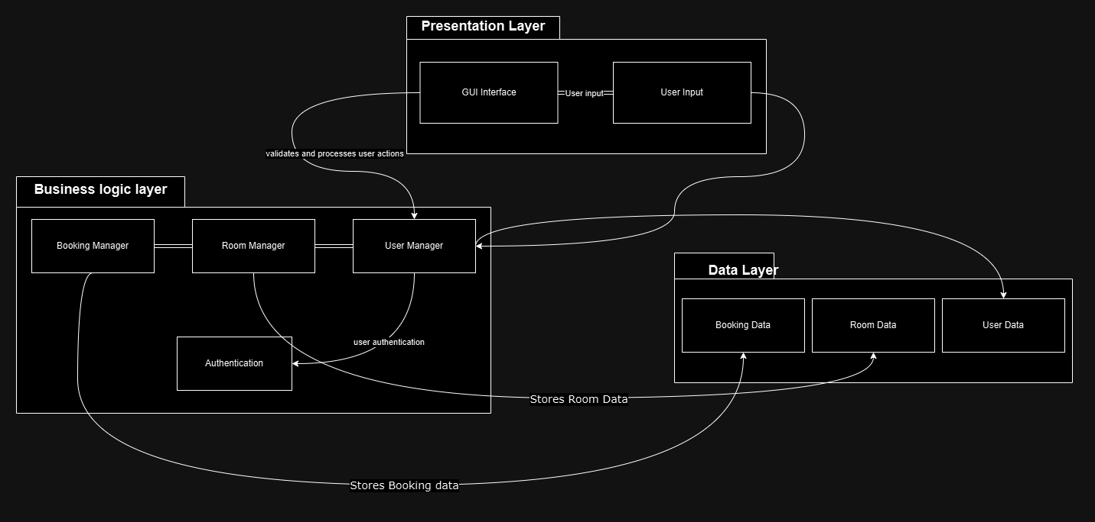
Component Diagram

- The Presentation Layer (GUI Interface) sends user input to the Business Logic Layer, which processes the request and communicates with the Data Layer.
- The Business Logic Layer includes components like the User Manager, Room Manager, Booking Manager, and Authentication for managing the core functions.
- The Data Layer stores user, room, and booking data, which is updated or retrieved as needed by the business logic.

- Use Case Modeling
  - Use Case Diagram

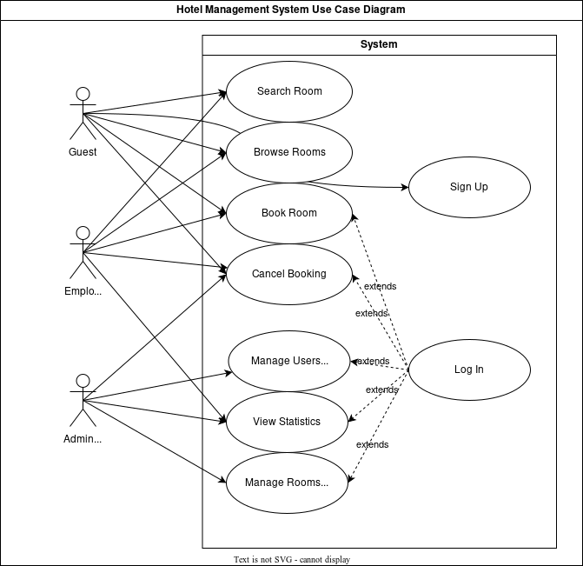

  - Use Cases
    - Admin Use Cases

      - Admin Login
- Description: Allows the administrator to securely log into the system.
- Precondition: Admin credentials must exist.
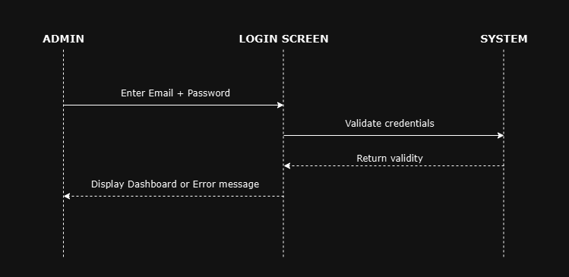

      - Manage Users
- Description: Allows the administrator to add, remove, or update user information.
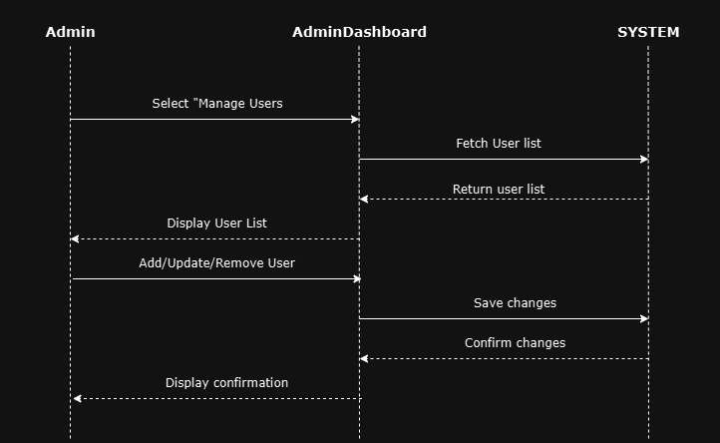
- Precondition: Admin must be logged in.
      - Manage Rooms
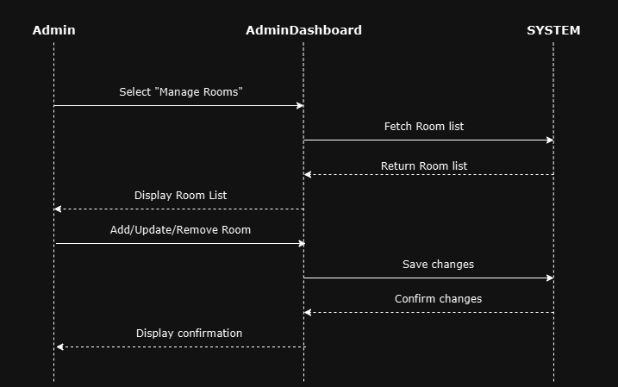
- Description: Allows the administrator to add, update, or remove rooms.
- Precondition: Admin must be logged in.
      - Search for a Room:
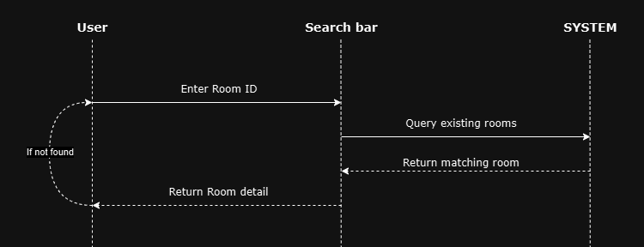
- Description: Allows the administrator to look for a specific room through its ID.
- Precondition: Admin must be logged in.

    - User Use Cases
      - User Registration
Description: Allows new users to create an account. Precondition: User must provide required information.
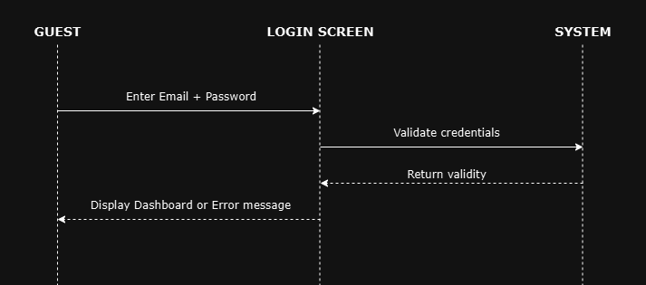

      - User Login
- Description: Allows registered users to log into the system.
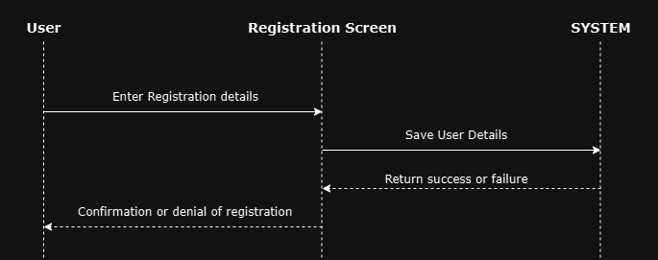
- Precondition: User credentials must exist.

      - View Room Availability
- Description: Allows users to check available rooms for specific dates.
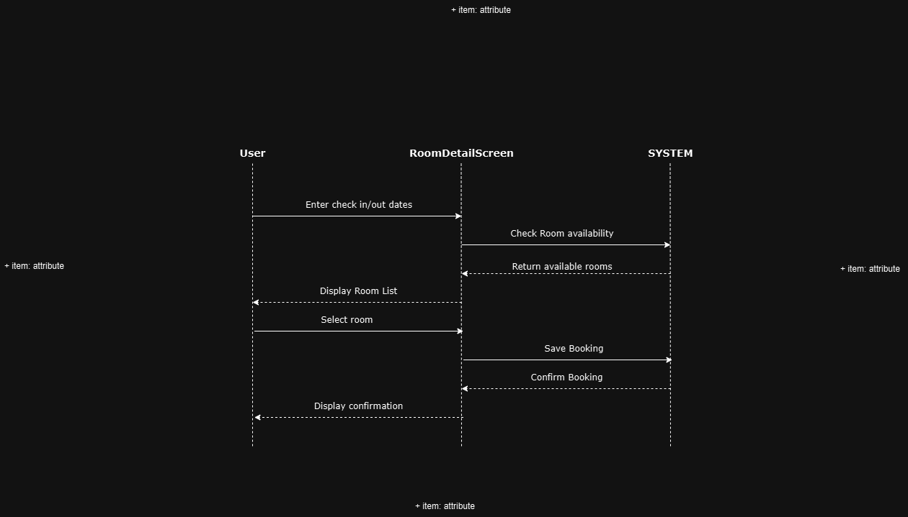
- Precondition: User must be logged in.
      - Book Room
- Description: Allows users to book a room after checking its availability.
- Precondition: User must be logged in, and room must be available.
      - Cancel Booking
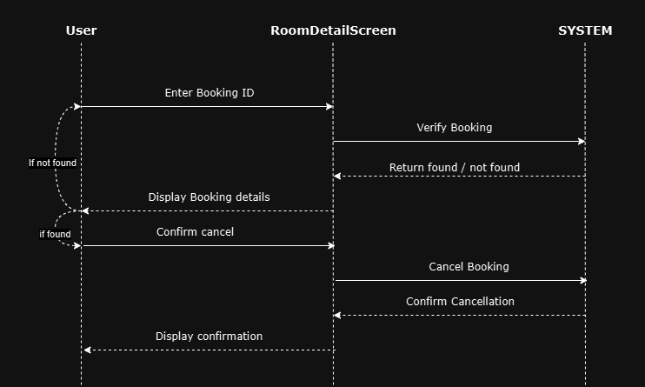
Description: Allows users to cancel their Booking. Precondition: User must be logged in, and booking must be valid.

Decomposition Description
5.1. User Authetication Module
Type: Application
Purpose: This module handles user registration and authentication.
Function: It allows users to register, log in or change their passwords.
Submodules:
Sign In
Log In
Change Password

5.1.1. Sign In
Type: Process
Purpose: Provides the user’s authorization level based on their credentials stored in the user table.
Function: The user enters their email and password into a web form. If the credentials match a record in the user table, the system assigns the user their respective authorization level.
Submodules: None

5.1.2. Sign Up
Type: Process
Purpose: Handles user registration if the user’s information is not already in the system.
Function: A visitor fills out the registration form and clicks the "Complete Registration" button. The user’s information is then stored, and the user is given a default status of "guest."
Submodules: None

5.1.3. Change Password
Type: Process
Purpose: Allows users to change their password.
Function: The user enters their old password and a new password. If the information provided is correct, the old password is replaced by the new one.
Submodules: None
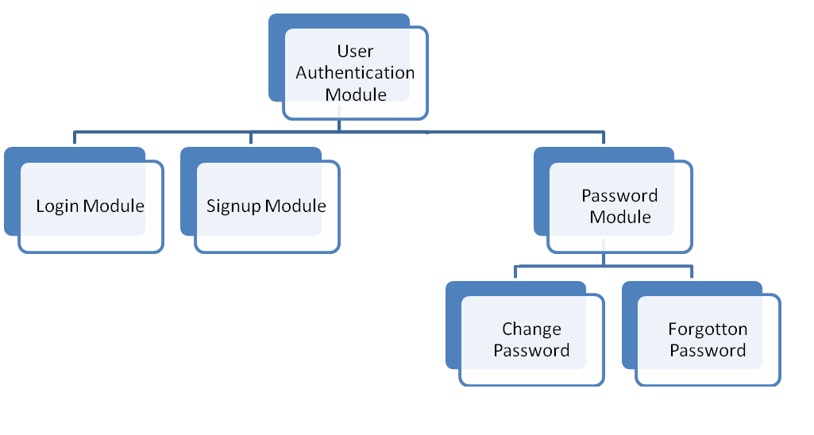

5.2. Online Reservation Module
Type: Application
Purpose: This module allows customers and staff to book or cancel room reservations.
Submodules:
Reserve Room
Cancel Reservation
5.2.1. Reserve Room
Type: Process
Purpose: Allows customers to reserve a room.
Function: The customer selects a room, specifies the check-in and check-out dates, and confirms the reservation.
Submodules: None
5.2.2. Cancel Reservation
Type: Process
Purpose: Enables customers to cancel an existing reservation.
Function: The customer selects the reservation they wish to cancel and confirms the cancellation.
Submodules: None

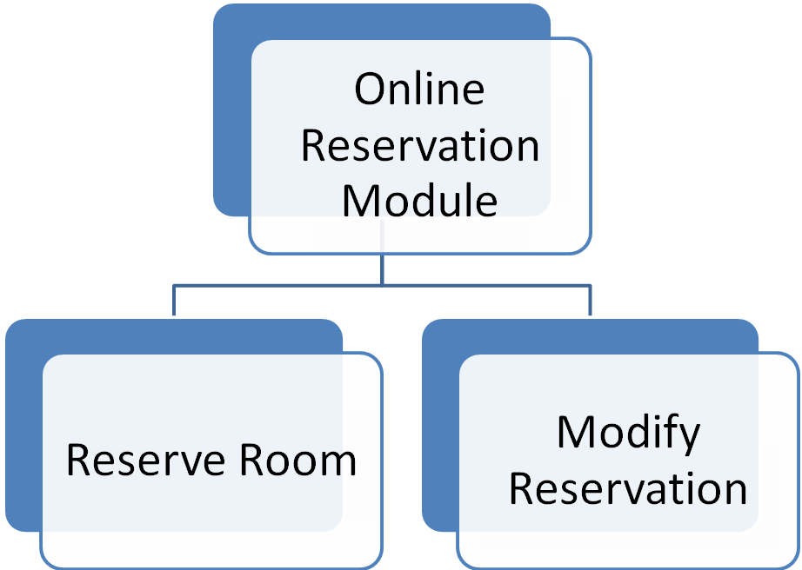

5.3. Manage Room Module
Type: Application
Purpose: Allows the administrator to manage room details.
Function: This module allows the administrator to add, delete, or modify room information (e.g., mark a room as occupied or vacated).
Submodules:
Add Room
Delete Room
Modify Room Information (Vacated/Occupied)
5.3.1. Add Room
Type: Process
Purpose: Allows the administrator to add a new room.
Function: The administrator clicks the "Add New Room" button, fills in the room specifications, and clicks the "Save" button to add the room.
Submodules: None
5.3.2. Delete Room
Type: Process
Purpose: Allows the administrator to delete a room.
Function: The administrator clicks the "Delete Room" button and confirms the action. Since room information is not permanently removed from the system, this process is reversible.
Submodules: None

5.3.3. Modify Room Information
Type: Process
Purpose: Allows the administrator to modify existing room details.
Function: The administrator clicks the "Modify Room Information" button, which enables them to change the room's details (e.g., availability status, room type, price).
Submodules: None
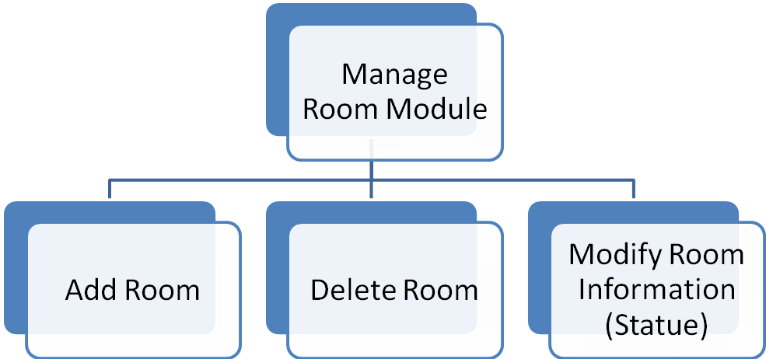

- Class Diagram
  - Overview of Classes
    - User Class
User
- String email
- String password
- int userId
- String firstName
- String lastName
- String phoneNumber
+ User(int userId , String firstName , String lastName , String email , String phoneNumber , String password)
+ getEmail(): String
+ getPassword(): String
+ getUserId(): int
+ getFirstName(): String

    - Administrator Class
Administrator
- Gestionnaire gestionnaire;
- List<User> users;
- List<Room> rooms
+ Administrateur()
- jButton1ActionPerformed(java.awt.event.ActionEvent evt)
- jButton2ActionPerformed(java.awt.event.ActionEvent evt)
- jButton3ActionPerformed(java.awt.event.ActionEvent evt)
    - Room Class
Room
- int roomNumber
- int price
- String bedType
- String description
- boolean available
+ Room(int roomNumber,int price,String bedType,String description)
+ getRoomNumber(): int
+ getPrice(): int
+ getBedType(): String
+ getDescription(): String
+ isAvailable(): boolean
+ setRoomNumber(int roomNumber): void
+ setPrice(int price): void
+ setBedType(String bedType): void
+ setDescription(String description): void
+ setAvailable(boolean available): void
+ toString(): String

    - Booking Class
Booking
- int id
- User user
- Room room
- LocalDate dateDebut
- LocalDate dateFin
- boolean paid
+ Booking(int id, User user, Room room, LocalDate dateDebut, LocalDate dateFin)
+ calculerMontant(): Double
+ libererChambre(): void
+ getId(): int
+ setId(int id): void
+ getUser(): User
+ setUser(User user): void
+ getRoom(): Room
+ setRoom(Room room): void
+ getDateDebut(): LocalData
+ setDateDebut(LocalDate dateDebut): void
+ getDateFin(): LocalDate
+ setDateFin(LocalDate dateFin): void
+ boolean isPaid(): boolean
+ setPaid(boolean paid): void

  - Class Diagram
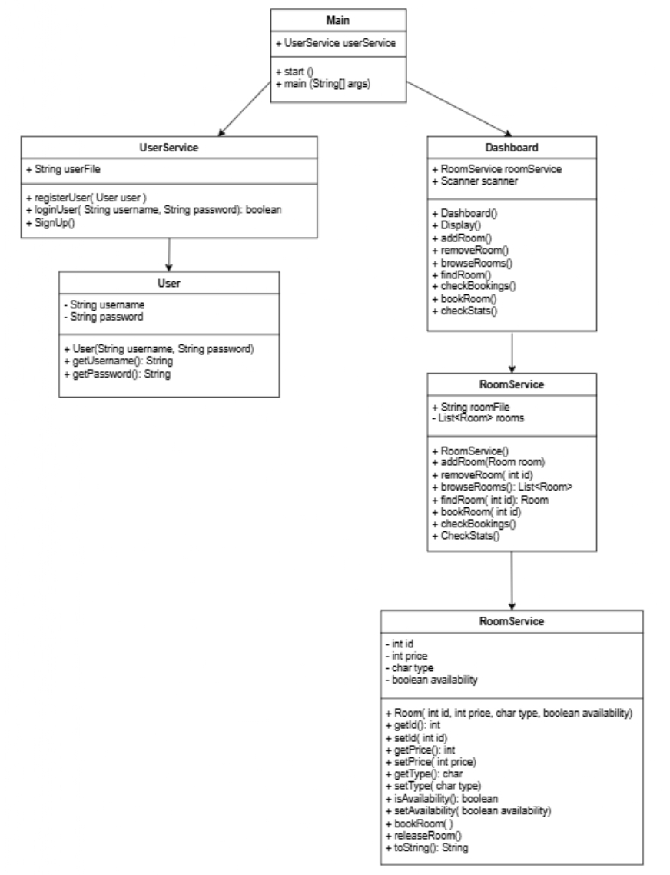

- Sequence Diagrams
  - Admin Login Sequence
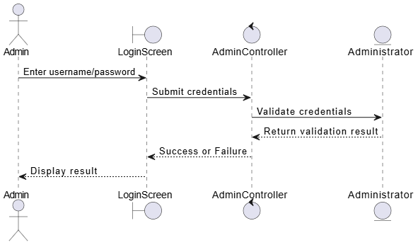
  - User Registration Sequence
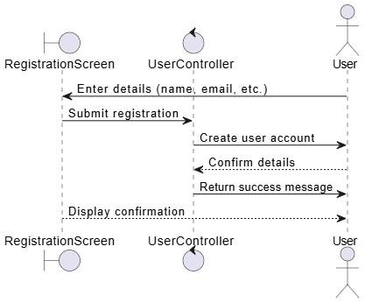
  - Room Booking Sequence
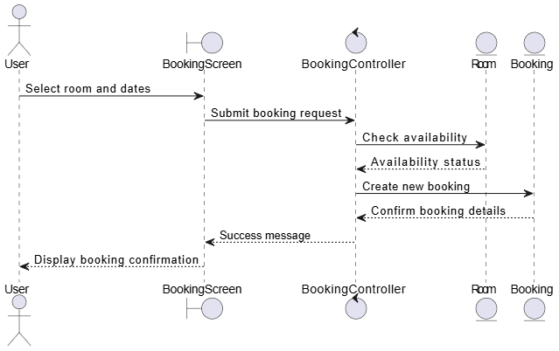
  - Sequence Diagrams
Manage users:
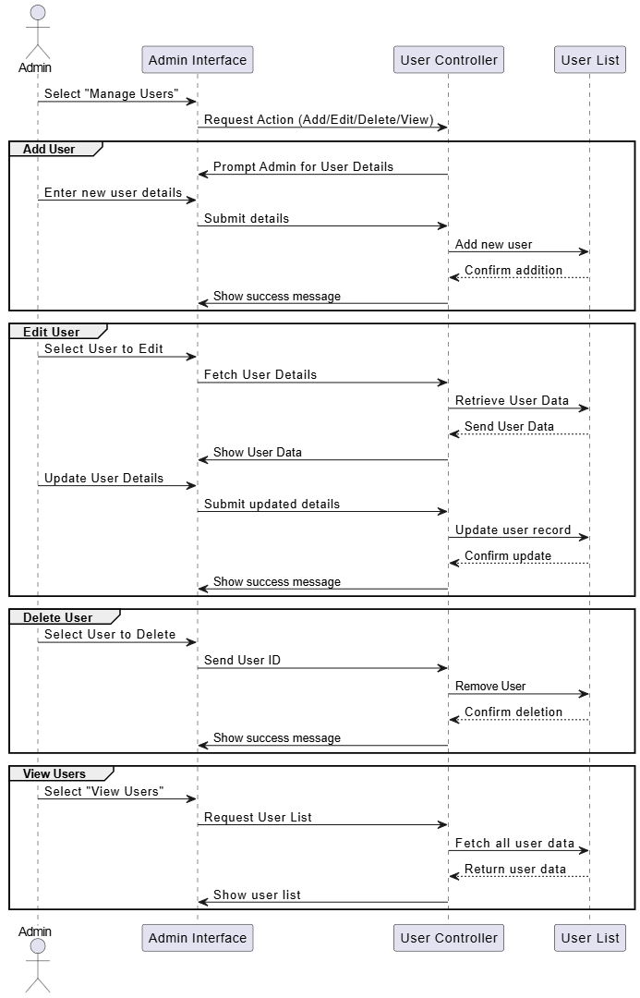
Manage rooms:
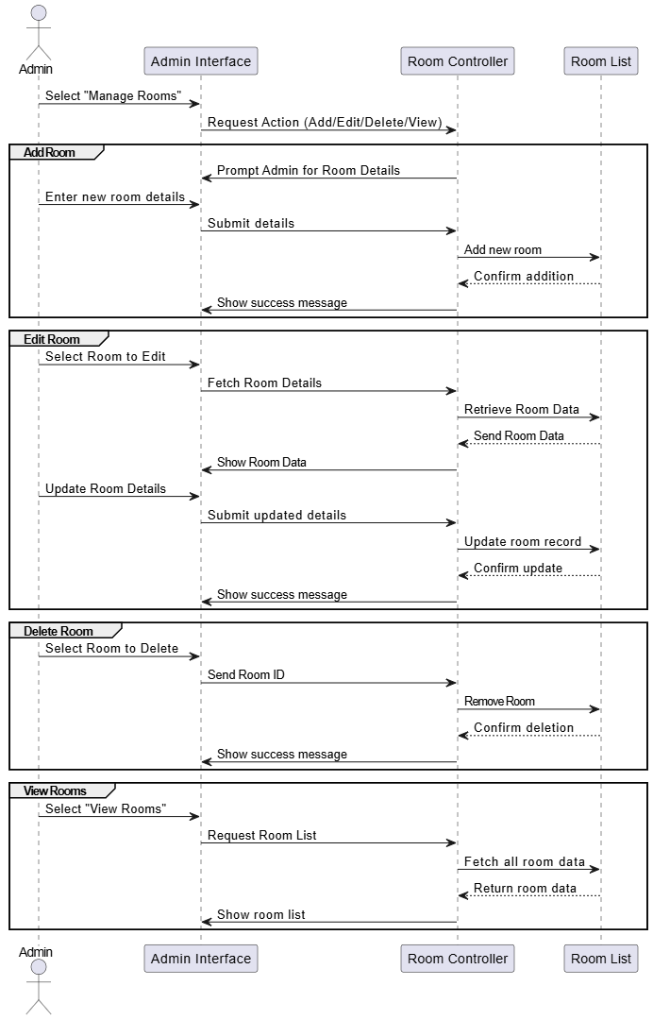

Error Handling and Validation

User Input Validation
    - Admin Input Validation:
When adding or updating rooms, input fields such as room name, room number, and capacity can be validated to ensure they are not empty and adhere to predefined formats.
    - User Registration Validation:
During user registration, the following fields are validated: First Name and Last Name: Should not be empty and contain only alphabets.
    - Authentication Errors
Admin Login:
  - If an incorrect username or password is entered, an error message is displayed to inform the user of invalid credentials.
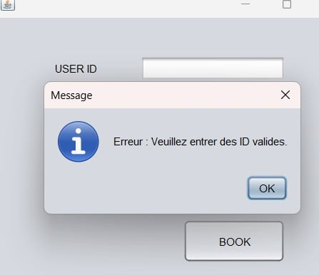

    - Data Integrity Checks.
- Room Management:
  - Ensures room numbers are unique when adding new rooms.
  - Checks that a room being edited or deleted exists in the list before performing the operation.
- Booking Data:
  - Verify that a room is available before confirming a booking.
  - Prevent double bookings of the same room.

Error Handling Mechanisms
- Graceful Error Messages:
  - Errors are communicated to the user in a clear, human-readable format.
- Prevent System Crashes:
  - Errors are handled using condition checks (if statements) instead of allowing runtime exceptions to propagate.
- Fallback Mechanism:
  - In the event of an error, the system can allow users to retry the operation or return to the main menu.

User Interface Design

UI Overview
The user interface (UI) is designed to be simple, intuitive, and user-friendly to meet the needs of both administrators and users. The system consists of two main interfaces:
- Admin Interface: Allows administrators to manage rooms, users, and bookings.
- User Interface: Allows guests to view room availability, book rooms, and check booking status.
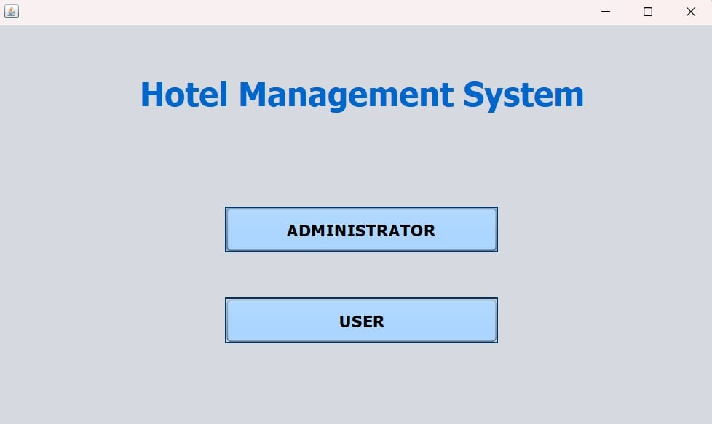

9.1.1. Admin Interface
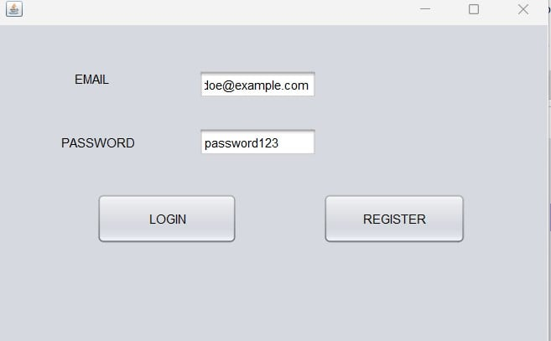
- Login Screen: Secure login form for administrators.

- Dashboard: A main panel displaying options such as:
  - Manage Users: Add, delete, or update user information.
  - Manage Rooms: Add, delete, or update room details.
  - Manage Bookings: Add, delete or modify a booking.
  - Users informations: Browse users
  - Room informations: Browse Rooms
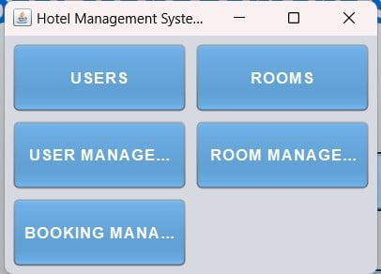
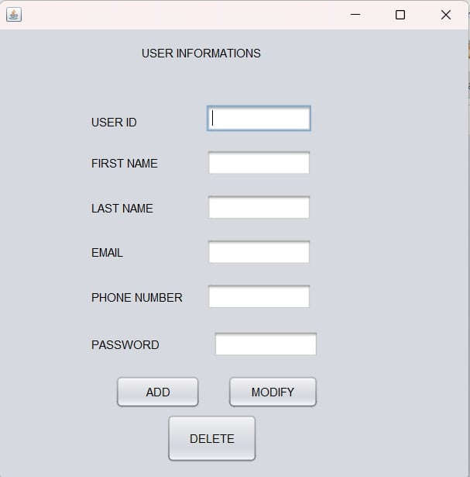
- Manage Users Screen:
  - A form to input user details (name, email, etc.).

- Manage Bookings Screen:
  - A form to input booking details (ID, dates, payment status).

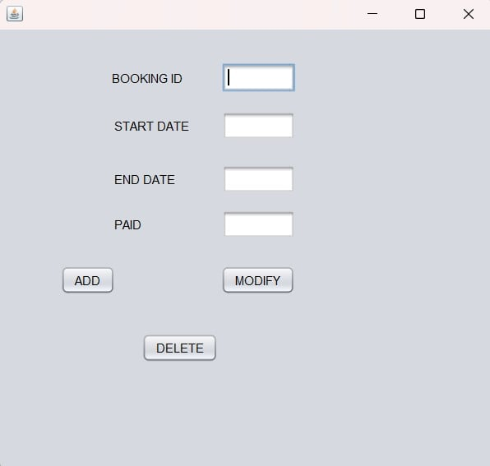

9.1.2. User Interface
- Home Screen:
  - Displays quick options like View Room Availability and Book a Room.
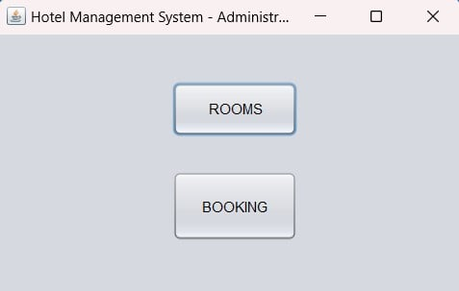
- Registration Screen:
  - A form for new users to register with details such as name, email, phone number, and password.
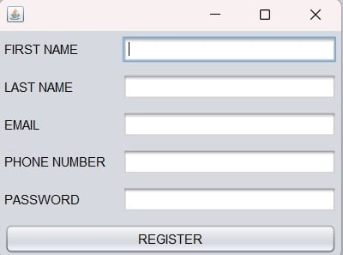

- Login Screen:
  - Allows registered users to log into the system.
- Room Booking Screen:
  - Allows users to book rooms by providing booking details.
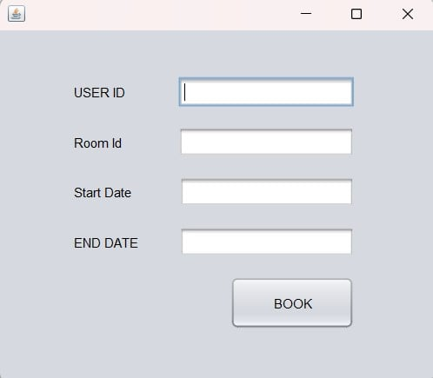

- Cancel Booking Screen:
  - Allows users to cancel an existing booking using their booking ID.
- Payement screen:
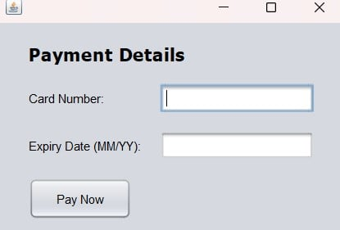

UI Flow Description

Admin Flow:
- Admin Login:
  - Admin enters valid credentials to access the system.
- Dashboard:
  - Admin chooses one of the following options:
    - Manage Users: Add, delete, or update user information.
    - Manage Rooms: Add, delete, or update room details.
    - View Reports: View summaries of bookings.

User Flow:
- Registration:
  - A new user registers their details to create an account.
- Login:
  - Registered users log in with their credentials.
- Room Booking:
  - Users view available rooms and book a room by submitting details.
- Check Booking Status:
  - Users enter a booking ID to view the current status.
- Cancel Booking:
  - Users provide a booking ID to cancel an existing reservation.

Deployment Plan

System Requirements

Hardware Requirements:
- Processor: 1.8 GHz or faster dual-core processor
- Memory: 4 GB RAM minimum
- Storage: 100 MB of free space for the application
- Display: Minimum resolution of 1024x768
- Input Devices: Keyboard and mouse or touchscreen for interaction

Software Requirements:
- Operating System: Windows 10 or higher, macOS, or Linux (Ubuntu preferred for development)
- Java Runtime Environment (JRE): Java 8 or later
- Java Development Kit (JDK): JDK 8 or later for development and execution
- IDE: IntelliJ IDEA (for backend development) or NetBeans (for frontend design)
- Database: Not applicable (no database is used in this project; data is managed via in-memory lists)

Installation Procedure

Step 1: Download the Source Code
- Clone or download the source code repository from the project repository.
- Make sure you have the latest version of the code.

Step 2: Install Java Development Kit (JDK)
- Ensure that JDK 8 or later is installed on your machine.
- You can download JDK from Oracle’s website or use OpenJDK for Linux systems.

Step 3: Set Up the IDE
- Install IntelliJ IDEA or NetBeans on your computer for development purposes.
  - For NetBeans, download the latest version that includes Java support.
  - For IntelliJ IDEA, you can download the community edition for free.

Step 4: Import the Project
- Open your IDE (NetBeans or IntelliJ IDEA).
- Select File > Open Project (NetBeans) or File > Open (IntelliJ).
- Locate the project folder and open it.

Step 5: Run the Application
- In IntelliJ IDEA or NetBeans, click on the Run button to launch the application.
- The system will start with the main window for administrators and users.

Configuration
The system is configured for local use without the need for a complex database setup. Configuration is primarily related to the application settings.

1. Configure Application Settings:
- Ensure that the Java Development Kit (JDK) and IDE are properly configured to compile and run Java applications.
- Since the system does not rely on a database, the list-based data structures for rooms, bookings, and users are already initialized in the code.

2. Application Data:
- Modify the initial data for rooms, users, and bookings in the source code as needed:
  - The Room class contains a list of available rooms.
  - The User class contains a list of registered users.
  - The Booking class holds the booking data.
- Any changes to the available rooms or registered users can be made by modifying the hardcoded lists directly in the code.

3. Network Configuration (Optional):
- To deploy the system on a networked server or distribute it for multiple users to access via a web interface, configure the network settings accordingly (e.g., setting up IP addresses or configuring firewalls).

Maintenance and Future Work

System Maintenance

1. Regular Updates:
- Bug Fixes: Regularly monitor the system for any bugs or issues reported by users. Apply patches and fixes as required to ensure smooth functionality.
- Code Refactoring: Refactor code as needed to improve readability, efficiency, and maintainability. This may include simplifying functions, optimizing algorithms, and removing redundant code.

2. Backup Procedures:
- Manual Backup: Since the system does not use a database and data is stored in-memory, ensure that users periodically backup important data such as room bookings and user registrations. This can be done by exporting data to text files or external systems if necessary.

3. Monitoring and Logging:
- System Performance Monitoring: Monitor the system's performance to ensure that it can handle the number of concurrent users and bookings. Perform load testing periodically to identify potential performance bottlenecks.

Known Issues and Limitations
While the hotel management system is functional and meets its primary objectives, there are certain known issues and limitations:

1. Limited Data Persistence:
- Since the system does not use a database, data persistence is limited. Once the application is closed, all in-memory data (e.g., bookings, users) is lost. This can be a significant limitation if the system needs to retain data across sessions.

2. Lack of Multi-User Support:
- The system is designed for single-user interactions (both administrator and regular users). It does not support simultaneous logins or multi-user management, which would be essential for a large-scale deployment.

3. User Interface Design:
- The user interface is simple, but it could be enhanced with better aesthetics, more user-friendly features, and modern design elements. Currently, the application may look outdated compared to other systems on the market.

4. Lack of Security Features:
- The system does not have robust security features, such as encrypted password storage or secure authentication methods, which are essential for a real-world application.

Conclusion

Summary of the Design
The HMS has been designed to meet the basic needs of hotel administration and user management. The system is structured around a simple, user-friendly interface with separate spaces for administrators and regular users. It allows administrators to manage users, rooms, and bookings, while users can register, search for rooms, and book them. Key features of the system include:
- User Management: Admins can manage users, view user details, and perform basic operations such as adding or removing users.
- Room Management: Admins can manage room availability, and users can search for rooms, check availability, and make bookings.
- Booking System: Both administrators and users can interact with the booking system, allowing for bookings, cancellations, and checking booking statuses.
- Simple Interface: The system has an intuitive graphical user interface (GUI) created with NetBeans, which provides a clean and responsive design.
- System Logic: The core logic is implemented using Java, focusing on clear, maintainable code that interacts seamlessly with in-memory data storage.

Final Thoughts

The hotel management system is feasible and efficient, making it a good solution for smaller-scale applications not dealing with data persistence or multi-user support. It works fine within the actual framework, although the further enhancements mentioned in the paper are bound to improve more on the durability, scalability, and general user experience of the system.

The system can be improved in flexibility and scalability by adding persistent storage solutions, more advanced reporting, and real-time data updates. Moreover, the addition of security measures and a mobile app version would further elevate the system, making it suitable for larger establishments with more complex requirements.

This project has ultimately yielded great understandings on the design and development of the system for real-world applicability. It has only made me realize how imperative robust software design methodologies and coherent system architecture are in conjunction with user-focused development when creating a successful and long-lasting application.

Appendices

Appendix A: Source Code Samples.
Sample 1: User Class

public class User {

private int userId;

private String firstName;

private String lastName;

private String email;

private String phoneNumber;

private String password;

public User(int userId, String firstName, String lastName, String email, String phoneNumber, String password) {

this.userId = userId;

this.firstName = firstName;

this.lastName = lastName;

this.email = email;

this.phoneNumber = phoneNumber;

this.password = password;

}

// Getters et Setters}
Sample 2: space and Login interfaces

public class Space extends javax.swing.JFrame {

public Space() {

initComponents();

}

private void jButton1ActionPerformed(java.awt.event.ActionEvent evt) {

new Login().setVisible(true);

this.dispose();

}

Appendix B: Glossary of Terms
- Admin: A system user who has the ability to manage users, rooms, and bookings.
- User: A system participant who can register, book rooms, and view booking status.
- Booking: A reservation made by a user for a room in the hotel.
- GUI (Graphical User Interface): The interface that allows users to interact with the system visually, instead of using command-line inputs.
- Authentication: The process of verifying the identity of an administrator or user within the system.
- In-memory Storage: A temporary data storage method using variables and collections like lists to store information during runtime.
- HMS: Hotel Management System.

Appendix C: References
- Java Documentation – Official documentation of Java programming language (https://docs.oracle.com/en/java/)
- NetBeans IDE – A development environment for Java, HTML, and other languages (https://netbeans.apache.org/)
- Draw.io – Diagramming tool used for creating UML diagrams (https://www.draw.io/)

User Agreement
Last Updated: 16/12/2024
This User Agreement governs the use of the our Hotel Management System by users who access and use the services provided by the system. By accessing or using our System, you agree to be bound by the terms and conditions of this Agreement. If you do not agree with these terms, you must not use our System.

1. User Registration
1.1. Eligibility
To register for an account with the System, you must provide accurate, current, and complete information as prompted by the registration form. You must be at least 18 years old or have the consent of a parent or legal guardian to use the System.
1.2. Account Responsibilities
You are responsible for maintaining the confidentiality of your account credentials (username and password). You are also responsible for all activities that occur under your account. If you notice any unauthorized use of your account, you must notify us immediately.

2. Use of the System
2.1 System Access
We grant you a limited, non-exclusive, non-transferable license to access and use the System for its intended purposes, subject to your compliance with this Agreement.
2.2 Prohibited Activities
You agree not to:
- Use the System for any illegal, harmful, or fraudulent activities.
- Attempt to reverse-engineer, decompile, or disassemble the System.
- Engage in any activity that could harm the functionality or integrity of the System.
2.3 System Availability
We strive to provide uninterrupted access to the System. However, we do not guarantee the availability of the System at all times and will not be liable for any system downtime or issues that may arise.

3. Privacy and Data Collection
3.1 Personal Information
As part of the registration process, we may collect personal information such as your name, email address, phone number, and other details required for providing services. This information will be used in accordance with our Privacy Policy.
3.2 Use of Data
By using the System, you consent to the collection, use, and sharing of your personal data as described in our Privacy Policy.

4. Booking and Cancellation Policy
4.1 Room Booking
Users may book rooms through the System. Availability and pricing of rooms are subject to change without notice.

4.2 Booking Modifications and Cancellations
Users can modify or cancel bookings through the System, subject to specific terms that may apply to cancellations or changes. Any cancellation fees or policies applicable to your booking will be outlined during the booking process.

5. Payment
5.1 Payment Methods
Payments for bookings may be required through approved methods. By making a payment, you agree to pay the amounts due for your booking as per the System’s pricing structure.
5.2 Refunds
Refunds, if applicable, will be processed according to the terms and conditions specified for cancellations and refunds in the System.

6. Limitation of Liability
6.1 No Warranty
The System is provided "as is" and we make no warranties or representations about the accuracy, reliability, or availability of the System or the services provided.
6.2 Limitation of Liability
We will not be held liable for any damages arising from the use of or inability to use the System, including but not limited to direct, indirect, incidental, or consequential damages.

7. Termination of Access
7.1 Termination by User
You may terminate your use of the System at any time by deleting your account or ceasing to use the System.
7.2 Termination by Us
We reserve the right to suspend or terminate your access to the System if we believe you have violated the terms of this Agreement.

8. Changes to this Agreement
We may modify or update this Agreement from time to time. All changes will be posted on this page with the updated date. By continuing to use the System after any modifications, you agree to be bound by the updated terms.

9. Governing Law
This Agreement shall be governed by and construed in accordance with the tunisian laws, without regard to its conflict of law principles.

10. Contact Us
For any questions, concerns, or disputes regarding this Agreement, please contact us at:
yasmine.essetti.2023@ihec.ucar.tn
or
nour.masmoudi.2023@ihec.ucar.tn

By using the our Hotel Management System, you acknowledge that you have read, understood, and agree to be bound by this User Agreement.
